**Question #1**  
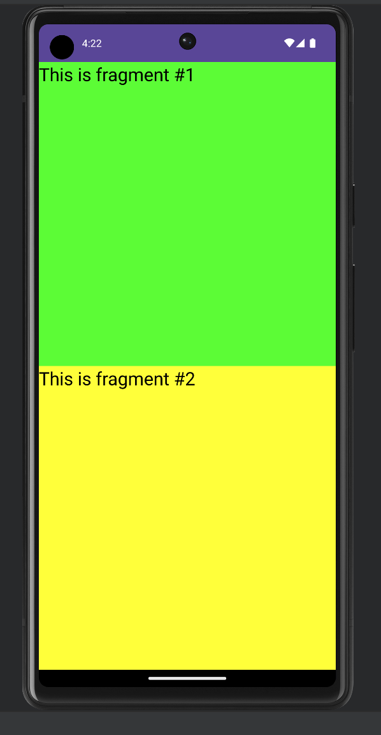

**Question #2**

**Question #3**